https://eur-lex.europa.eu/legal-content/EN/TXT/HTML/?uri=CELEX:52020DC0662

EU COM Renovation Wave strategy
Introduction, point 3 : « Renovation is held back by barriers at different points throughout the value chain – from the initial decision to engage in renovation, to financing and completion of the project. For instance, when considering a renovation, benefits from energy savings might be uncertain or poorly explained and understood, especially by the end-users. They can be difficult to measure and monetise 15 . Renovating can also be costly, difficult to organise and lengthy to carry out. Mobilising financing can be difficult, in particular at local and regional level. Public funds are frequently scarce and difficult to blend due to regulatory obstacles and lacking capacity in public administrations.”
Given the low risk profile of energy efficiency investments 40 and the demand prospects that a renovation wave will underpin, offering private financing jointly with innovative services for renovation will be an increasingly attractive business proposition. Actors like ESCOs, utilities or banks already use and provide technical advice. They can offer property owners much-needed support in terms of ideas and financing in all phases of a renovation process. They can promote the aggregation of small projects, offer favourable conditions for complex projects with long payback times and unite the various actors involved in taking buildings renovation decisions.
Secondly, Member States can reduce risk perception and scale up market incentives such as energy-saving tariffs, pay-per-performance public support schemes and energy-saving tenders to attract private intermediaries and aggregators. Member States should also explore innovative financing solutions through on-tax and on-bill schemes or property-linked finance, a well as taxation tools 41 to generate economic incentives to finance building renovation. Existing energy efficiency obligation schemes under Article 7 of the Energy Efficiency Directive can be effectively used for all types of buildings 42 to engage new intermediaries like utilities, deliver technical expertise and offer aggregated services to reduce transaction and administrative costs.
Involving ESCOs through public-private partnerships is a possibility to attract investment, pool together small-scale and scattered investments, reduce upfront costs and reward the energy savings. Coupling energy performance contracts with resilience contracting by insurers can help the market manage investment risk because insurers have expertise on assessing and offering protection against environmental, climate and other risks.
To help reduce transaction costs, the Commission will encourage the standardisation of contracts and financial instruments at national and European level, by using existing forums to help replicate and scale up best practices and innovative approaches. The Commission will actively support these ways of activating private-sector investments through the Energy Efficiency Financial Institutions Group (EEFIG) and the Sustainable Energy Investment (SEI) Forums.
A renovation wave can also be an opportunity to spur the development of green loan and mortgage financing. An upgraded system of EPCs demonstrating efficiency gains will allow banks and other financial institutions to offer credit and mortgage financing to green their portfolios and to pool buildings as a collateral for the issuance of covered bonds. A number of market-led initiatives are already piloting innovative schemes for energy efficiency loan and mortgage financing 43 . In a next step, whole life-cycle carbon can be included in this assessment and linked to financing for circular solutions.
With the EU Renewed Sustainable Finance Strategy, the Commission is looking into additional standards and labels for sustainable financial products, such as green mortgages, green loans and green bonds. This will help make sure energy and resource efficiency lending products are offered more widely and are more visible to consumers. The reviews of the Mortgage Credit Directive 44 and the Consumer Credit Directive 45 provide opportunities to adequately reflect a possible lower credit risk of sustainable financial products 46 . Moreover, the European Banking Authority is analysing whether a dedicated prudential treatment in bank regulation of financial products associated with sustainability objectives, such as building renovation, would be justified. The Commission is also considering measures to incorporate environmental, social and governance risks into prudential regulation in its reviews of the rules for banks (the Capital Requirements Regulation and Directive) and insurers (the Solvency II Directive). The EIB will also consider supporting new ways to attract private finance for building rehabilitation, including unlocking new markets in energy efficiency mortgage-based lending or securitisation.
Finally, the Commission is developing the EU Taxonomy 47 , with technical screening criteria for the buildings sector, to direct private capital towards sustainable investments in energy renovation, relying on Energy Performance Certificates and nearly zero-energy building standards. As part of the EPBD revision, the Commission will also consider introducing a ‘deep renovation’ standard, to enable anchoring significant private financing to transparent, measurable and genuinely “green” investments.
All these initiatives can help customers to access funding on cheaper terms and help promoting the development of dynamic private financing complementing public funds, tax incentives and other forms of public financial support.

https://iea.blob.core.windows.net/assets/dfd9134f-12eb-4045-9789-9d6ab8d9fbf4/EnergyEfficiency2023.pdf

See Property assessed clean energy financing section : PACE is a major tool for leveraging private financing in carrying out energy efficiency improvements.

https://www.nber.org/system/files/working_papers/w26766/w26766.pdf

WHEN AND HOW TO USE PUBLIC-PRIVATE PARTNERSHIPS IN INFRASTRUCTURE: LESSONS FROM THE INTERNATIONAL EXPERIENCE

In infrastructure context -> PPP = funded by mix of user fees and govt transfers.

Why choose PPPs (pol economy) ?
- Most of spending does not show up in public spending/debt figures.
- Less parliamentary etc oversight, and therefore more discretionary control.
- PPP as second-best when privatisation is not achievable.
Note that in reality 1) does not imply a net gain in fiscal space : the present value of a project is the same whether govt retains ownership or not (i.e. ability to levy tolls etc).

Economic rationales for PPP :

Efficiency gains : note that private firms are involved even in public building (e.g. as designers, maintainers, operators…) ; therefore any efficiency gains vs public ownership should stem from the incentive structure.
- Esp when creating SPVs etc : narrowness of scope + private-law nature of contracts.
- Bundling, e.g. of construction and operation, encourages life-cycle approaches towards investment and maintenance. Better alignment of incentive.
- Fewer construction delays (i.e. if fees etc can only be levied once the project is achieved).
- Project filtering : absent government transfers, firms will only be interested in projects for which user fees can cover capital and current expenditure.
- Avoiding efficiency shortfalls of public bureaucracies (whether stemming from justifiable public service rigidity or corruption).
- Private financing implies stricter oversight by e.g. banks, and less moral hazard.
- More frequent, and thus better/less expensive maintenance : mostly in cases where quality of service can be stipulated as a contract clause.

“Subcontracting tasks to private firms has been the main means whereby private incentives were brought into public provision. PPPs represent a different organizational form that goes beyond hiring contractors to build a project. Under a PPP, the private concern creates a private entity—a so called special purpose vehicle or SPV— in charge of financing, delivering and operating a public project. While the relation between the state and the SPV is still governed by public law, the SPV is a private firm and its contracting relations with employees, other firms, and financiers are governed by private law. This improves incentives, because during the term of the PPP, the SPV has discretion to manage the infrastructure as a private firm. Moreover, by creating an SPV, the scope of the firm is clearly defined and limited, and the project gets a dedicated management team, which answers to the SPV board.”

https://academic.oup.com/jeea/article-abstract/11/1/83/2299428
Public–private partnerships (PPPs) have been justified because they release public funds or save on distortionary taxes. However, the resources saved by a government that does not finance the upfront investment are offset by giving up future revenue flows to the concessionaire. If a PPP can be justified on efficiency grounds, the PPP contract that optimally balances demand risk, user-fee distortions, and the opportunity cost of public funds has a minimum revenue guarantee and a revenue cap. The optimal contract can be implemented via a competitive auction with reasonable informational requirements. The optimal revenue guarantees, revenue sharing agreements, and auction mechanisms are different from those observed in the real world. In particular, the optimal contract duration is shorter in demand states where the revenue cap binds. These results also have implications for budgetary accounting of PPPs, as they show that their fiscal impact resembles that of public provision, rather than privatization.
https://onlinelibrary.wiley.com/doi/epdf/10.1111/jpet.12114

The Simple Microeconomics of Public-Private Partnerships

https://publications.ut-capitole.fr/id/eprint/1206/1/ppp.pdf

Public-Private Partnerships and Government Spending Limits
We consider public-private partnerships, in which a public official selects a project that is then developed and operated by a private contractor. We derive optimal public accounting rules when the official's choice among projects is biased by ideology or social ties or because of pandering to special interests. We give particular emphasis to how the rules should constrain the official’s incentive to understate the costs of her pet projects. In the basic model, we show that the optimal accounting rule takes the form of a budget cap, with a project’s expected cost modified to reflect the official’s distortionary incentives. If the project can be partially financed privately, then “fixed-price” contracts can serve to curb political misbehavior by “securitizing” public sector liabilities. We also consider the possibility that development and operations are each handled by different contractors. Such “unbundling” deprives public accountants of forward information about future costs, but can prevent the official from funneling hidden future rents to contractors. Public–private partnerships (PPPs) have been justified because they release public funds or save on distortionary taxes. However, the resources saved by a government that does not finance the upfront investment are offset by giving up future revenue flows to the concessionaire. If a PPP can be justified on efficiency grounds, the PPP contract that optimally balances demand risk, user-fee distortions, and the opportunity cost of public funds has a minimum revenue guarantee and a revenue cap. The optimal contract can be implemented via a competitive auction with reasonable informational requirements. The optimal revenue guarantees, revenue sharing agreements, and auction mechanisms are different from those observed in the real world. In particular, the optimal contract duration is shorter in demand states where the revenue cap binds. These results also have implications for budgetary accounting of PPPs, as they show that their fiscal impact resembles that of public provision, rather than privatization.

https://documents1.worldbank.org/curated/en/712651468025506948/pdf/758250WP0P12450h0to0Climate0Finance.pdf
- Alternative framework to Clean Development Mechanism (established during Kyoto protocol, meant to channel funding from GHG-emitting entities in developed countries to emissions-reducing projects in developing countries). The latter had failed to scale up and provide adequate amounts of funding ; was channeled too often into low capital/labour projects ; recurrent issues with windfall profits. Mostly “end-of-pip” mitigation funding of existing (low-tech) assets rather than pushing shift towards renewables etc. Funding based on (volatile) carbon pricing, and delivered only after emissions reductions are produced (i.e. not available for initial capitalisation). Overly stringent standards on additionality.

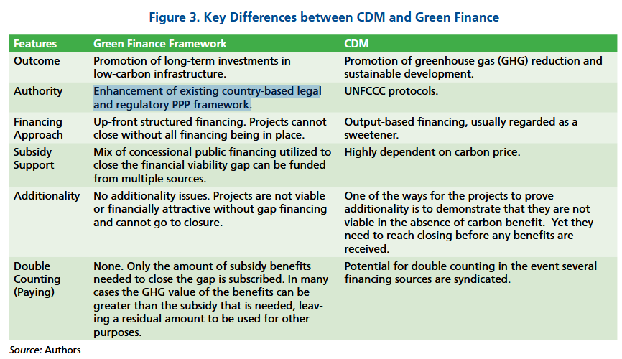
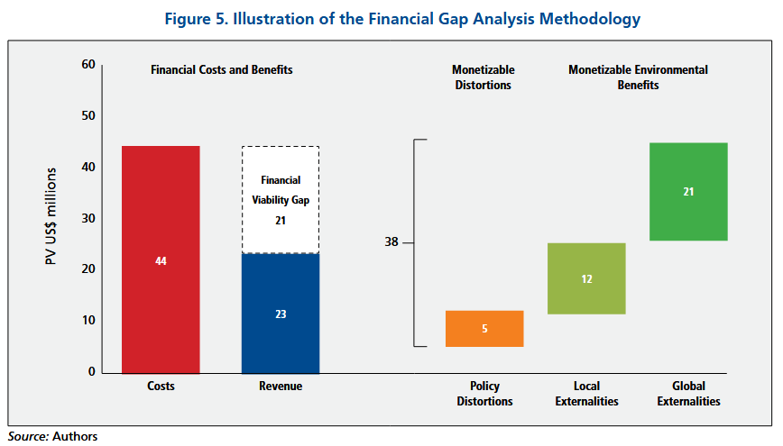

New framework in lieu of CDM recognises need for MRV (measuring, reporting, valuing) and other strong regulatory/reporting frameworks, which are anchored in national contexts ; it would be based on the existing national PPP framework of legally enforceable contracts (i.e. for service obligations and other deliverables), procurement rules, non-compliance sanctions.
- Allows for cheaper, simpler auditing of projects on an incremental basis rather than baseline GHG assessment.
https://documents1.worldbank.org/curated/en/343711468343734503/pdf/684910PUB0EPI0067926B09780821395271.pdf

https://infrastructure-toolkit.oecd.org/infragov-theme/green/

EU/MS policies
https://eur-lex.europa.eu/legal-content/EN/TXT/?uri=CELEX:52020DC0021

Green Deal/Sustainable Europe Investment Plan (2020)

1tn for green investment over 10 years, including (?300-470bn?) of crowding of private investment.
Of the 260bn/year extra investment identified to meet objectives, buildings sector has the most significant needs.

“As the investment pillar of the European Green Deal, the Sustainable Europe Investment Plan will mobilise at least EUR 1 trillion of sustainable investments over the next decade. This amount of financing for the green transition is achieved through spending under the EU’s long-term budget, a quarter of which will go to climate-related purposes, and including estimated EUR 39 billion for environmental expenditures. Moreover, the Plan will crowd in additional private funding through leveraging the EU’s budget guarantee under the InvestEU Programme. »
+ EIB becoming “EU’s climate bank”, raising its share of financing for climate action and environmental sustainability to 50%.

InvestEU guarantee feeds into EIB + national promotional banks and IFIs -> 279bn of private/public investment mobilised.
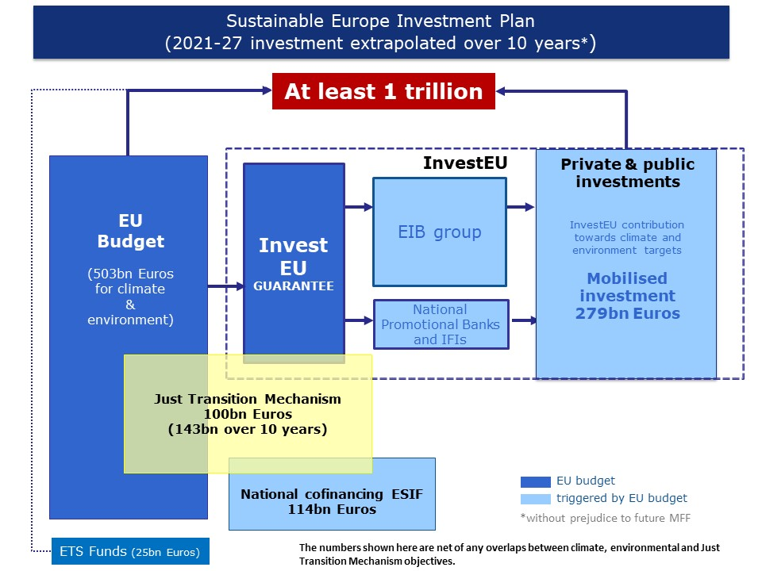

InvestEU to mobilise 650bn investments over 7 years
- 30% at least for climate ( 195bn over 7years, or 28bn/year).
“The Commission will:
-Ensure that EIB operations financed under EU mandates provide high additionality, both in terms of sectors covered and of the risk profile of financed projects. This will be done notably by enhancing the reporting and monitoring system, including the climate-tracking methodology. “

“The European Green Deal sets a clear direction for a comprehensive policy framework for the transformation of the EU economy. The 2050 climate neutrality objective will be enshrined in legislation and the ambition for greenhouse gas emission reductions in 2030 will be raised. The European Green Deal policies will use a mix of regulation and incentives to address externalities and implement the “polluter pays” principle, so that costs for society are reflected in investment decisions. The EU Emissions Trading System will be reviewed and will further help to ensure effective carbon pricing. Specific initiatives will address sector-specific regulatory barriers, such as obstacles to the funding and execution of energy efficiency investments in the building sector. »

Sustainable (private) finance as key to mobilsing large sums need for a favourable environment -> steps such as enhancing discolusre, EU taxonomy etc.

Stratégie FR

https://www.ecologie.gouv.fr/sites/default/files/documents/PNIEC_France_mars_2020.pdf
https://www.ecologie.gouv.fr/sites/default/files/documents/Plan%20de%20r%C3%A9novation%20%C3%A9nerg%C3%A9tique_0.pdf
voir notamment rappel des défauts du CITE et raisons de sa refonte.

https://www.google.com/url?sa=t&source=web&rct=j&opi=89978449&url=https://publications.jrc.ec.europa.eu/repository/bitstream/JRC133984/JRC133984_01.pdf&ved=2ahUKEwiNiY-MqK2PAxXweqQEHbchMmoQFnoECBgQAQ&usg=AOvVaw3-iVcqXRLT5xQ4xmMjiX2K

JRC report on EU Energy Performance Contracting markets
[see also for EU energy efficiency policy context]
This report reviews the status and future development of the EU Energy Performance Contracting (EnPC) markets. Fundamentally, EnPC constitutes an opportunity to bridge the investment gaps faced by the EU to meet its energy efficiency targets, energy performance of buildings and decarbonisation. This is important in the context of revised commitments of the EU to climate neutrality, energy independence and advancing the green economy, which are laid out in the European Green Deal, the Climate Target Plan 2030, the Next Generation EU, the Renovation Wave communication, and the RePowerEU.
Energy services, overall, create an incentive for the client to engage in energy efficiency projects, allowing them to recover investment, transaction, and service costs. Depending on the contract, the client can free economic resources since investments can be provided by or through the provider. EnPC is an energy service contract whereby the providers’ remuneration is linked to the successful delivery of the contracted savings.
Two major modalities of EnPC exist, i.e. a) guaranteed savings, whereby the client takes the financing risk (financing is therefore on the clients’ balance sheet), and b) shared savings, whereby the provider brings about the financing means. In the latter case, the project can result in an off-balance sheet arrangement for the client. EnPC has been promoted via public policies in the EU and its MSs as a part of a toolset to foster projects involving investment in energy efficiency, renewables, and other technological improvements resulting in energy and cost-savings during the service lifetime of technologies, buildings, systems, and infrastructures.

“The EU and MSs recognize the need to leverage private investment to achieve the necessary energy system transformation and untap energy performance's potential. The JRC report of 2021 (Moles-Grueso, et al. 2021) assessed the impacts of a broad range of policy and decision changes: the 2018 amendments on the Energy Efficiency (EED) and the Energy Performance of Buildings (EPBD) Directives, the Eurostat Guidance Note of 2017 and the Eurostat and EIB Guide of 2018;”

“Following up on the 2018 Action Plan on Sustainable Finance, the Commission’s Strategy for Financing the Transition to a Sustainable Economy (European Commission, 2021) calls for an increased alignment of public, private, international and multilateral capital to attain environmental, social and climate targets. Accelerating energy efficiency action in the building and other sectors calls for a more dynamic role of private financing instruments and the finance sector. The EEFIG (European Commission. Directorate General for Energy. et al., 2022) claims that “Achieving the EU’s targets for energy efficiency and emissions reduction … will require mobilizing significant amounts of private capital through a variety of appropriate financing instruments.””
https://eur-lex.europa.eu/legal-content/EN/TXT/?uri=CELEX:52021DC0390

Strategy for Financing the Transition to a Sustainable Economy (2021)
“As the scale of investment required is well beyond the capacity of the public sector, the main objective of the sustainable finance framework is to channel private financial flows into relevant economic activities. Private interest in sustainable investment has grown considerably in recent years but requires a framework for sustainable finance which is clear, consistent and robust. The EU is putting that framework in place.”
https://eur-lex.europa.eu/legal-content/EN/TXT/?uri=OJ%3AJOL_2023_231_R_0001&qid=1695186598766

Energy Efficiency Directive
(2023, orig 2012 and 2018 – revised as part of Green Deal package of 2021)

https://eur-lex.europa.eu/eli/dir/2024/1275/oj/eng
Recast 2024
- “Additionality is a fundamental underlying principle of the energy savings obligation provided for in this Directive, in so far as it ensures that Member States put in place policies and measures specifically designed for the purpose of fulfilling the energy savings obligation. New savings should be additional to ‘business as usual’, so that savings that would have occurred in any event should not count towards fulfilling the energy savings obligation. In order to calculate the impact of the measures introduced, only net savings, measured as the change of energy consumption that is directly attributable to the energy efficiency measure in question implemented for the purpose of the energy savings obligation provided for in this Directive, should be counted. To calculate net savings, Member States should establish a baseline scenario of how the situation would evolve in the absence of the measure in question. The policy measure in question should be evaluated against that baseline. Member States should take into account minimum requirements provided by the relevant legislative framework at Union level and the fact that other policy measures may be carried out in the same time frame which may also have an impact on the amount of energy savings, so that not all changes observed since the introduction of a particular policy measure can be attributed to that policy measure alone. The actions of the obligated, participating or entrusted party should in fact contribute to the achievement of the energy savings claimed in order to ensure the fulfilment of the materiality requirement.”

129:
It is necessary to continue developing the market for energy services to ensure the availability of both the demand for and the supply of energy services. Transparency, for example by means of lists of certified energy services providers and available model contracts, exchange of best practices and guidelines greatly contribute to the uptake of energy services and energy performance contracting and can also help stimulate demand and increase the trust in energy services providers. In an energy performance contract the beneficiary of the energy service avoids investment costs by using part of the financial value of energy savings to fully or partially repay the investment carried out by a third party. That can help attract private capital which is key for increasing building renovation rates in the Union, bring expertise into the market and create innovative business models. Therefore, non-residential buildings with the useful floor area above 750 m2 should be required to assess the feasibility of using energy performance contracting for renovation. That is a step ahead to increase the trust in energy services companies and pave the way for increasing such projects in the future.

138:
The financing facilities could in particular use contributions, resources and revenues from those resources to enable and encourage private capital investment, in particular drawing on institutional investors, while using criteria ensuring the achievement of both environmental and social objectives for the granting of funds; make use of innovative financing mechanisms, including loan guarantees for private capital, loan guarantees to foster energy performance contracting, grants, subsidised loans and dedicated credit lines, third-party financing systems, that reduce the risks of energy efficiency projects and allow for cost-effective renovations even among low- and medium-revenue households; be linked to programmes or agencies which will aggregate and assess the quality of energy saving projects, provide technical assistance, promote the energy services market and help to generate consumer demand for energy services.

Note also EEOs are explicitly cited as a viable tool for achieving efficiency (with other policies as “alternatives”).(-> Art 7 sets up obligation )

Art. 24 :
ensure access to ﬁnance, grants or subsidies bound to minimum energy gains and thus facilitate access to affordable bank loans or dedicated credit lines.
Art 30 : MS national energy efficiency funds, financing, technical support provision.

“By 31 December 2024, the Commission shall provide guidance for Member States and market actors on how to unlock private investment.
The guidance shall have the purpose of helping Member States and market actors to develop and implement their energy efficiency investments, including in the various Union programmes, and shall propose adequate financial mechanisms and innovative financing solutions, with a combination of grants, financial instruments and project development assistance, to scale up existing initiatives and use the Union programmes as a catalyst to leverage and trigger private financing.”

“Where Member States set up national energy efficiency funds, as referred to in paragraph 11 of this Article, they shall establish financing instruments, including public guarantees, to increase the uptake of private investments in energy efficiency and of the energy efficiency lending products and innovative schemes referred to in paragraph 3 of this Article. »

“The Commission shall assess the effectiveness and efficiency of energy efficiency public funding support at Union and national level and the Member States’ capacity to increase the uptake of private investments in energy efficiency, while also taking into account public financing needs expressed in the national energy and climate plans. The Commission shall evaluate whether an energy efficiency mechanism at Union level, with the objective of providing a Union guarantee, technical assistance and associated grants to enable the implementation of financial instruments, and financing and support schemes at national level, could support in a cost-effective way the achievement of the Union energy efficiency and climate targets, and, if appropriate, propose the establishment of such a mechanism.”

ANNEX recast Energy Performance of Buildings Financial incentives, skills and market barriers (Article 17) and one-stop shops (Article 18)

https://energy.ec.europa.eu/document/download/40f29e74-65a6-4a5d-ad1f-c20d9ff75f04_en?filename=Financial%20incentives%2C%20skills%20and%20market%20barriers%20%28Article%2017%29%20and%20one-stop%20shops%20%28Article%2018%29%20-%20annex%202.pdf
Directive (EU) 2024/1275

Developing Economies :
https://www.greenfinanceplatform.org/sites/default/files/downloads/resource/Plugging_energy_efficiency_gap_with_climate_finance_IEA.pdf

EE gap :

https://www.aeaweb.org/articles?id=10.1257/jel.20161360
https://www.journals.uchicago.edu/doi/epdf/10.1093/reep/ret021
https://www.sciencedirect.com/science/article/pii/S0306261919319944?casa_token=y0VIZhnjU5sAAAAA:IqMWdZGLqhDi7Rniq1DZ7ol2q4X1ieR3JidWQMW-rZGbXbzSPgH601n9Z8aQLmH_XgY3wvcV7A
Access to upfront capital remains a primary barrier in residential energy efficiency adoption. Government-sponsored programs exist for low-income households while traditional financing serves creditworthy households. However, there remains a coverage gap for those with moderate incomes too high to qualify for low- income programs, but without access to friendly capital. With limited research in this space, this study aims to: (1) develop a model to estimate the number of households in the coverage gap; and (2) explore their spatial distribution. For the state of Michigan, we used data from the US Census Bureau and approximately 12,000 green bank loans to estimate the energy efficiency financing coverage gap across the state's 83 counties using a binomial mixed model. We found that credit score and income interacted to largely determine whether an applicant was approved. Households in the highest income quintile achieved a 50% chance of approval with a moderate credit score (662) while those in the lowest needed a very high credit score (715) for the same odds. Overall, this created an estimated 12% energy efficiency financing coverage gap of households statewide, with individual county levels between 0% and 24%. Broadly, understanding the market potential and spatial distribution of this coverage gap could allow impact-driven financiers such as green banks or community development financial institutions to expand programs that may offer alternative underwriting criteria. Expanding loan access to this underserved market can promote energy system improvements, policy goals, household living conditions, and an equitable clean energy transition.

EE policy :
https://www.sciencedirect.com/science/article/abs/pii/S0301421513010768
Better methods of characterizing and addressing heterogeneity in preferences and decision making are needed to stimulate reductions in household greenhouse gas emissions. Four residential energy efficiency programs were delivered consecutively in the Region of Waterloo, Canada, between 1999 and 2011, and each offered a unique combination of information, financial reward structure, and price. A natural quasi-experimental intervention design was employed to assess differences in outcomes across these program structures. Participation at the initial (evaluation by an energy advisor) and follow-up (verification of retrofit) stages, and the material characteristics (e.g., energy performance) were measured and compared between the groups of houses included in each program at each stage. The programs appealed to people with different types of material concerns; each phase of the program was associated with houses with a different mix of material characteristics and depths of recommended and achieved changes. While a performance-based reward attracted fewer houses at each stage than a larger list-based reward, older houses with poorer energy performance were included at each stage. The findings support experimentation with program designs to target sub-populations of housing stock; future program designs should experiment more carefully and with larger performance-based rewards and test parallels with potential carbon market structures.

Policy packaging or policy patching? The development of complex energy efficiency policy mixes
https://www.sciencedirect.com/science/article/pii/S2214629616302638
The ambition of energy policy has long been to reduce carbon emissions, secure energy supply and provide affordable energy services. In recent years an increasing number of policy instruments have been introduced to promote energy efficiency in different sectors across the EU. While previous research has largely analysed the effectiveness of individual policy instruments and their impact on the diffusion of particular energy efficient technologies or practices, our analysis takes a broader view and examines the mix of existing policies aimed at stimulating reductions in energy use. The empirical focus of the paper is on policy goals and instruments aimed at stimulating energy efficiency in buildings in Finland and the United Kingdom (UK). We trace the development of the policy mixes during 2000–2014 and analyse their emerging overall characteristics. The analysis is based on a mapping of policy goals and instruments, documentary analysis and semi-structured interviews with stakeholders. We find that both countries have increasingly complex policy mixes, encompassing a variety of goals and instruments and make use of a range of different instrument types to encourage users to reduce their energy consumption. Despite the shared EU influence, the way in which the policy mixes have evolved in both countries were found to be quite different.

iea.blob.core.windows.net/assets/1c9f0a29-e440-4cbc-839a-9b1916818267/IEAEnergyEfficiencyPolicyToolkit_2025_Online.pdf

IEA EE Policy Toolkit 2025

https://www.sciencedirect.com/science/article/abs/pii/S0301421518308395

Worth the risk? An evaluation of alternative finance mechanisms for residential retrofit
Improving energy efficiency, de-carbonising heating and cooling, and increasing renewable microgeneration in existing residential buildings, is crucial for meeting social and climate policy objectives. This paper explores the challenges of financing this ‘retrofit’ activity. First, it develops a typology of finance mechanisms for residential retrofit highlighting their key design features, including: the source of capital; the financial instrument(s); the project performance requirements; the point of sale; the nature of the security and underwriting the repayment channel and customer journey. Combining information from interviews and documentary sources, the paper explores how these design features influence the success of the finance mechanisms in different contexts. First, it is shown that a low cost of capital for retrofit finance is critical to the economic viability of whole-house retrofits. Second, by funding non-energy measures such as general improvement works, finance mechanisms can enable broader sources of value that are more highly prized by households. Thirdly, mechanisms that reduce complexity by simplifying the customer journey are likely to achieve much higher levels of uptake. Most importantly we discuss how finance alone is unlikely to be a driver of demand for whole-house retrofit, and so instead should be viewed as a necessary component of a much broader retrofit strategy.
http://www.cied.ac.uk/publication/comprehensive-instrument-mixes/

The need for comprehensive and well targeted instrument mixes to stimulate energy transitions: The case of energy efficiency policy
Energy transitions are complex and long-term processes and require a variety of public policy interventions to steer their direction and speed to achieve global climate change mitigation targets. One area where policy support is required is energy efficiency, which offers a high potential for carbon savings. It is widely acknowledged that energy efficiency improvements will need to be faster and deeper than is currently the case and this requires policy instrument mixes to support both those energy efficiency measures that are simple and cost-effective as well as more complex and costly technologies. In other words, policy mixes need to be well-targeted and comprehensive. This paper addresses the issue of comprehensiveness in terms of technology-specificity and the level of complexity and costliness of energy efficiency measures.
https://www.sciencedirect.com/science/article/abs/pii/S0301421517303634

Identifying policy solutions for improving the energy efficiency of rental properties
World leaders have acknowledged that climate change is one of the biggest challenges we face in the 21st century and have committed to pursuing efforts to limit warming to 1.5 degrees above pre-industrial levels (UNFCCC, 2015). To do this, further efficiencies in energy use are needed across all sectors, many of which still offer considerable potential for improving energy efficiency. Rental properties in particular, have seen very few improvements in energy efficiency due to a range of barriers and market failures including misinformation, split incentives and an uneven power dynamic between renters and landlords. This is important as not only do rental properties account for a significant proportion of housing stock, the high proportion of low income households in rental properties are particularly vulnerable to rising energy prices. This study aimed to identify feasible policy solutions for overcoming the barriers to energy efficiency improvements in rental properties. Renters, landlords and agents were presented with five possible solutions to determine their level of support. Eight key recommendations for overcoming the barriers to energy efficiency improvements in rental properties are provided. These create a foundation for policy makers, councils and businesses to develop and target energy efficiency solutions for rental properties.
https://euea-energyagency.org/wp-content/uploads/2012/08/FinancialBarrierBuilding.pdf

Financing Energy Efficient Homes IEA 2007

https://publications.jrc.ec.europa.eu/repository/handle/JRC123755

Financing energy renovations at local and regional levels
It is widely recognised that much of the energy we use in buildings is largely wasted due to old construction practices, many of which preceded the adoption of energy performance standards. With over 80% of today’s buildings expected to be still in use in Europe by 2050, the building sector must be at the centre of decarbonisation efforts in the EU. Energy upgrades through comprehensive renovations can drive much needed energy savings in the sector, boost economic growth, generate new jobs, support local businesses and strengthen industrial competitiveness. Renovations can also play a crucial role in the European recovery of the COVID-19 pandemic due to the labour-intensive nature of the building sector and large domination of local businesses. In light of the close link of regional and local authorities with European citizens, this report assesses the role of municipalities and regions in stimulating energy upgrades in residential, commercial and public buildings today. Based on data collected through a survey conducted with the help over 80 experts across European regions and municipalities, the report assesses the main financial and fiscal instruments and identifies their main characteristics. Good practices are discussed based on the selection of various design, implementation and impact criteria, ranging from funding sustainability to scalability and success at addressing hard-to-reach groups.

https://op.europa.eu/en/publication-detail/-/publication/a3032517-c761-11ec-b6f4-01aa75ed71a1/language-en

Report on the evolution of financing practices for energy efficiency in buildings, SME's and in industry
Energy efficiency investments must more than double to achieve the EU’s new climate and energy targets. This EEFIG report takes a deep dive into the current status and identifies necessary actions to scale up energy efficiency investments in buildings, SMEs and industry.

https://www.sciencedirect.com/science/article/abs/pii/S0301421515002359?via%3Dihub

Achieving affordable housing through energy efficiency strategy
Cooperation between public and private sector has achieved a remarkable widespread, in the Italian context, over the last two decades. Nevertheless, the increasing difficulty in accessing the capital market and the rising cost of funding sources, both noticeable over the past few years, led to a slowdown of Public–Private Partnership (PPP) initiatives. Meanwhile, the community is expressing new needs to be satisfied, such as the conversion of brownfields, the recovery of housing stock dating back to former times, as well as the refurbishment of public offices or schools. Emerging priorities include the supply of affordable dwellings for low to medium income households.
https://op.europa.eu/en/publication-detail/-/publication/e73247dd-c321-4ed0-84d9-cb5a8a1e282a/language-en

Energy-efficient buildings PPP (2010)
The construction sector accounts nowadays for around 30 million jobs in the EU. Buildings also represent 40% of energy use and 33% of greenhouse gas emissions in Europe. The European Economic Recovery Plan, launched a year ago to address the current crisis, includes a new Research Public-Private Partnership (PPP) aimed at developing building and district concepts having the potential to reduce energy use. The "Energy-efficient Buildings" (EeB) initiative is a € 1 billion programme in which the European Commission and industry will support research on sustainable technologies for the EU construction sector. The aim is to develop energy-efficient materials and systems for new and renovated buildings which can help to radically reduce their energy consumption and C02 emissions. In these Research Priorities for the Definition of a multi-annual Roadmap and Longer Term Strategy for the EeB PPP, besides the horizontal aspects, three major challenges have been identified: (i) Refurbishment to transform existing buildings into energy-efficient buildings, (ii) Neutral or energy-positive new buildings and (iii) Energy-efficient districts and communities. The public-private efforts to support research in these areas will contribute to a successful European strategy for industrial growth in a greener economy.
https://publications.jrc.ec.europa.eu/repository/handle/JRC117816

Accelerating energy renovation investments in buildings (2019)
Policy context
To address the issue of underinvestment in energy efficiency, revisions in 2018 to the
Energy Performance of Buildings Directive 2010/31/EU and Energy Efficiency Directive
2012/27/EU, have strengthened the existing policy and financial framework. New
elements include the reinforcement of existing financial instruments, establishment of
new financial models or supporting mechanisms and a more active participation of
financial institutions. In line with these actions, the European Commission launched the
Smart Finance for Smart Buildings Initiative in 2016, with the aim to further mobilise
private financing for sustainable energy in buildings. This initiative stresses the
importance of more effective use of public EU funding and the need to de-risk energy
efficiency investments in buildings by giving investors and private financiers a better
understanding of the risks and benefits of energy efficiency. A solid financial component
has also been underlined as a prerequisite for the successful implementation of the long-
term building renovation strategies set up by the EU Member States in accordance with
the Energy Performance of Buildings and Energy Efficiency Directives.

Key conclusions

Our research has shown that EU Member States currently deploy various public support
instruments, each tailored to address specific barriers, segments and recipient groups
within the sector. These are primarily in the form of grants/subsidies, followed by soft
loans and tax incentives which target residential, commercial and public buildings. Our
findings indicate that around EUR 15 billion are roughly spent by public resources on an
annual basis across the EU. This is in line with findings from previous studies suggesting
an investment gap for the Paris agreement 2°C goal (Maio, Zinetti and Janssen, 2012;
Hudson, Schopp and Neuhoff, 2013; Amon and Holmes, 2016; Ogunlana and Goryunova,
2017). While private investments are not included in our findings, achieving the goals set
out by the Paris agreement and the EU would require significantly higher levels of
funding (IEA, 2017). A shift towards more sustainable public financing means (e.g. from
grants to guarantees) which can leverage higher levels of private funds would also be
needed to meet the investment scalability needs, together with limiting access to grants
to vulnerable or difficult-to-access groups and exploring new, innovative mechanisms.
The use of private financial schemes on energy efficiency is generally less studied in the
literature due to the vast range of business models and actors involved as well as
difficulty in accessing data concerning private lending practices. Whilst many private
actors choose to conduct energy efficiency upgrades using their own funds, financial
institutions have become more active than ever before at offering specialised financial
products geared towards energy efficiency investments. More than half of the private
schemes identified in this study were enacted in the last 4 years. At the same time, new
models based on non-conventional methods of raising funds are currently explored as a
vehicle to drive more investments. Examples reviewed in this study include crowdfunding
for energy efficiency, which gives access to consumers who would not normally be

https://blogs.worldbank.org/en/ppps/europes-green-deal-needs-ppp-thinking

Blog post : Europe’s Green Deal needs PPP thinking

